NX3224K024

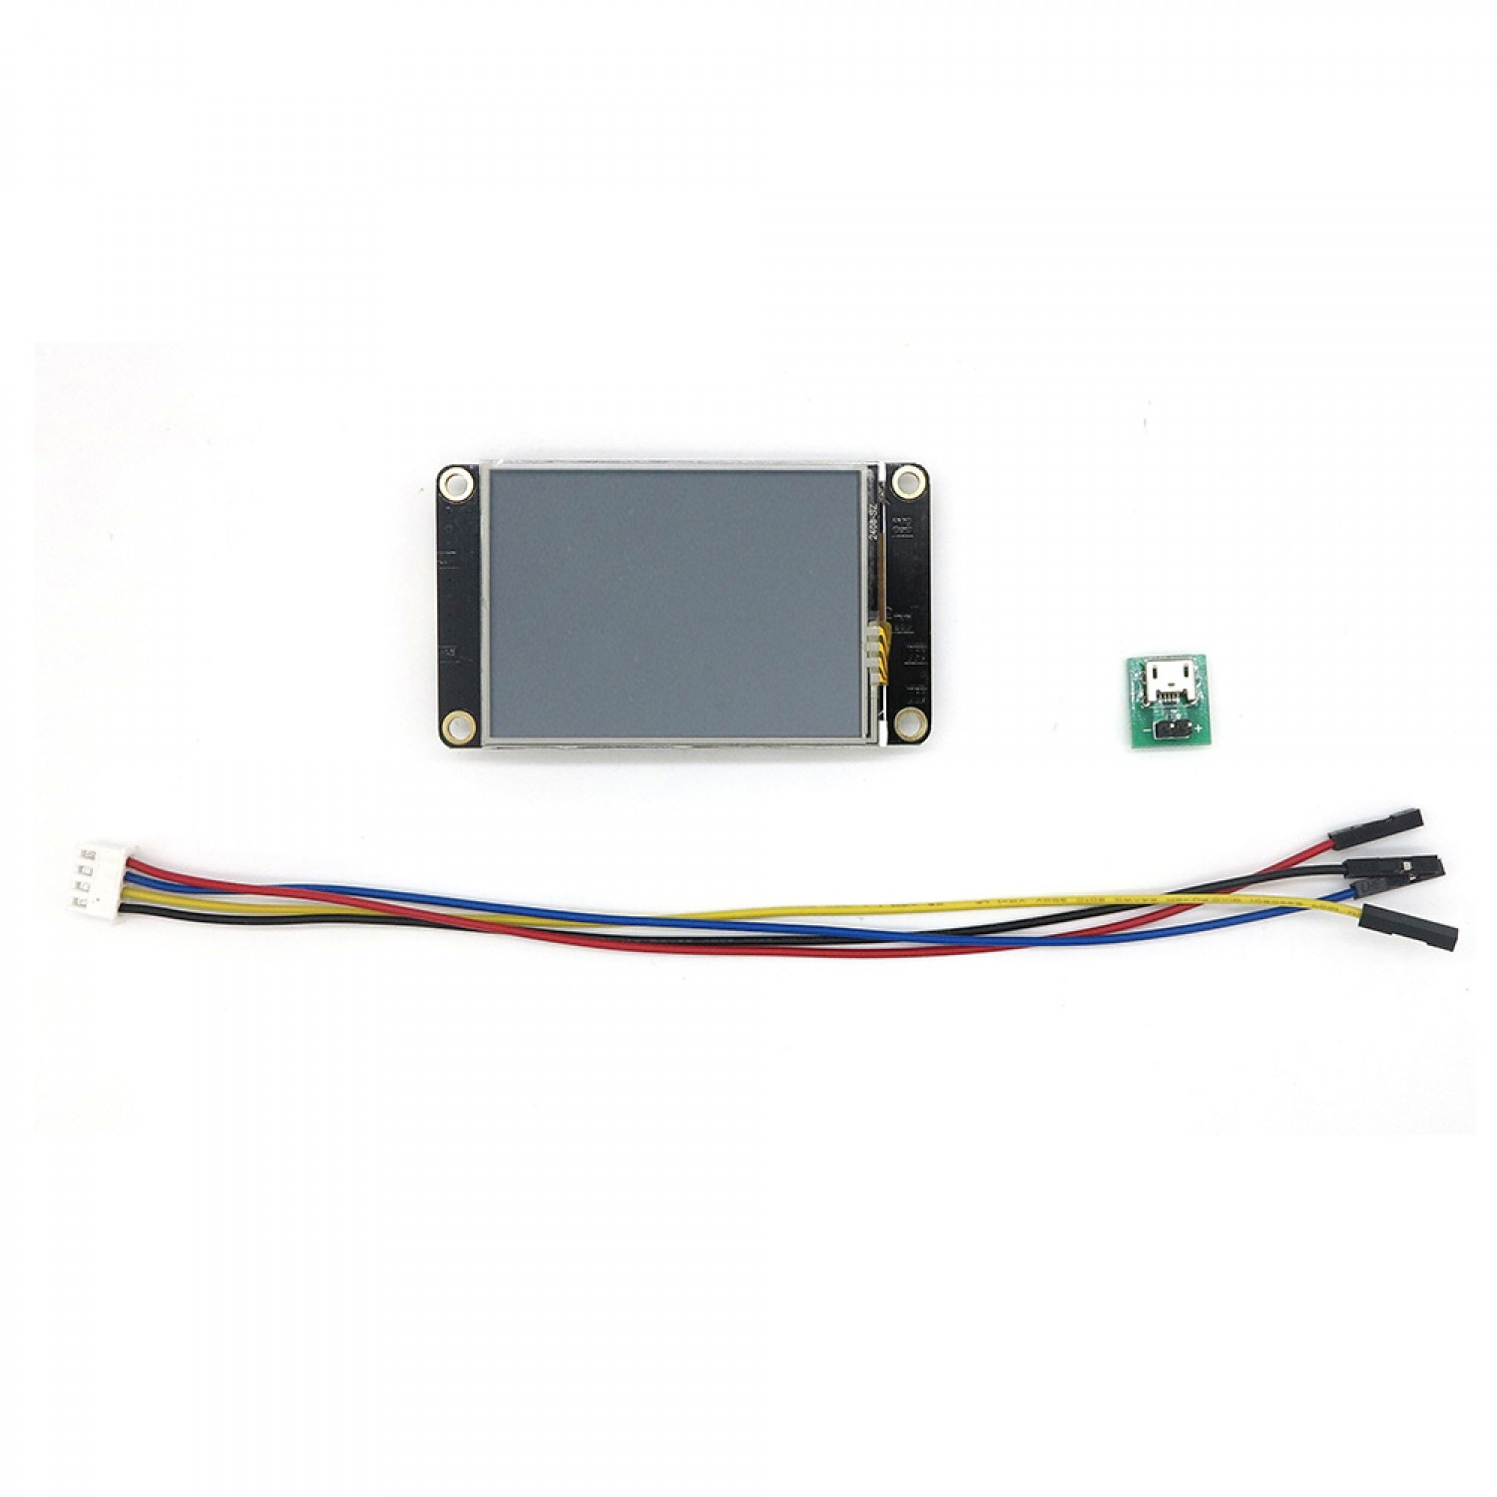

**Tinytronics:**

<https://www.tinytronics.nl/shop/nl/displays/embedded/nextion/nextion-enhanced-nx3224k024-hmi-display-2.4-inch-320x240-met-touchscreen>

**Datasheet:**

<https://nextion.tech/datasheets/nx3224k024/>